

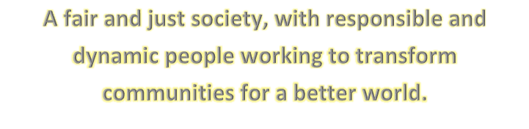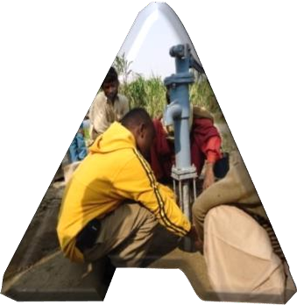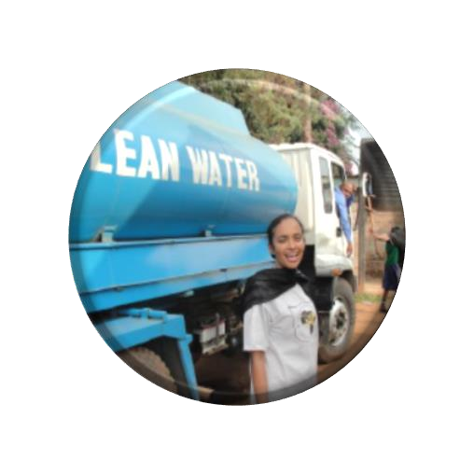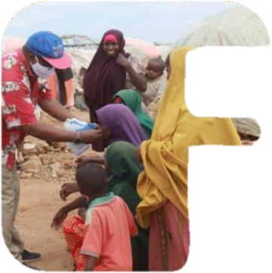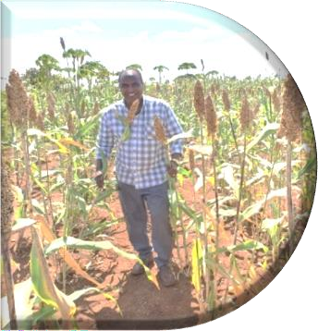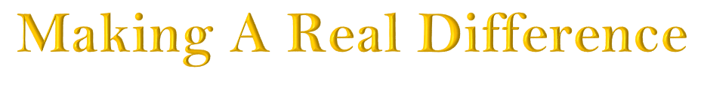



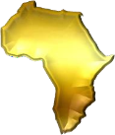

Focus On Africa Development Inc.

FOAD Kenya, Junction Garden, Riara Road, Lovington, Unit 13, Nairobi, Kenya, Tel: +254 718 719 413/ +254 724 379 358

FOAD Somalia, Km 4 Hodan District, Mogadishu, Banadir State, Somalia. Tel: +252 615 995 159 The Market Shopping Centre, M. Peace Plaza, Kigali, Rwanda Office Room No. 23, 3rd Flr, Block 8.

Tel: +250790778256/+250787522968.

FOAD Australia. 42 Jackson Parade, North Coburg, VIC 3058 Australia





# Content:

1. **Introduction… Page 1**
2. **Our Status Page 2**
3. **Strategic Priorities Page 3**
4. **Our Policies Page 4**
   * Child Protection
   * Religious, political and Welfare activities
   * Gender Policy
5. **Water hygiene and sanitation Page 6**
6. **Environment page 7**
7. **Livelihood’s development Page 8**
8. **Health care Page 9**
   * Covid-19 response and prevention
   * Maternal and child health program
   * Tropical diseases response program
   * Sexual and Reproductive Health Rights
9. **Humanitarian Response… Page 15**
10. **Snap-shot of our history**

# Introduction

Page 1

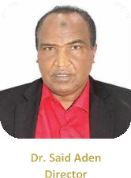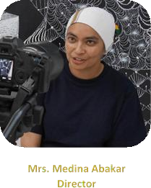

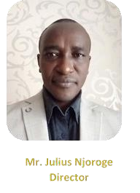













# Our Status

Page 2

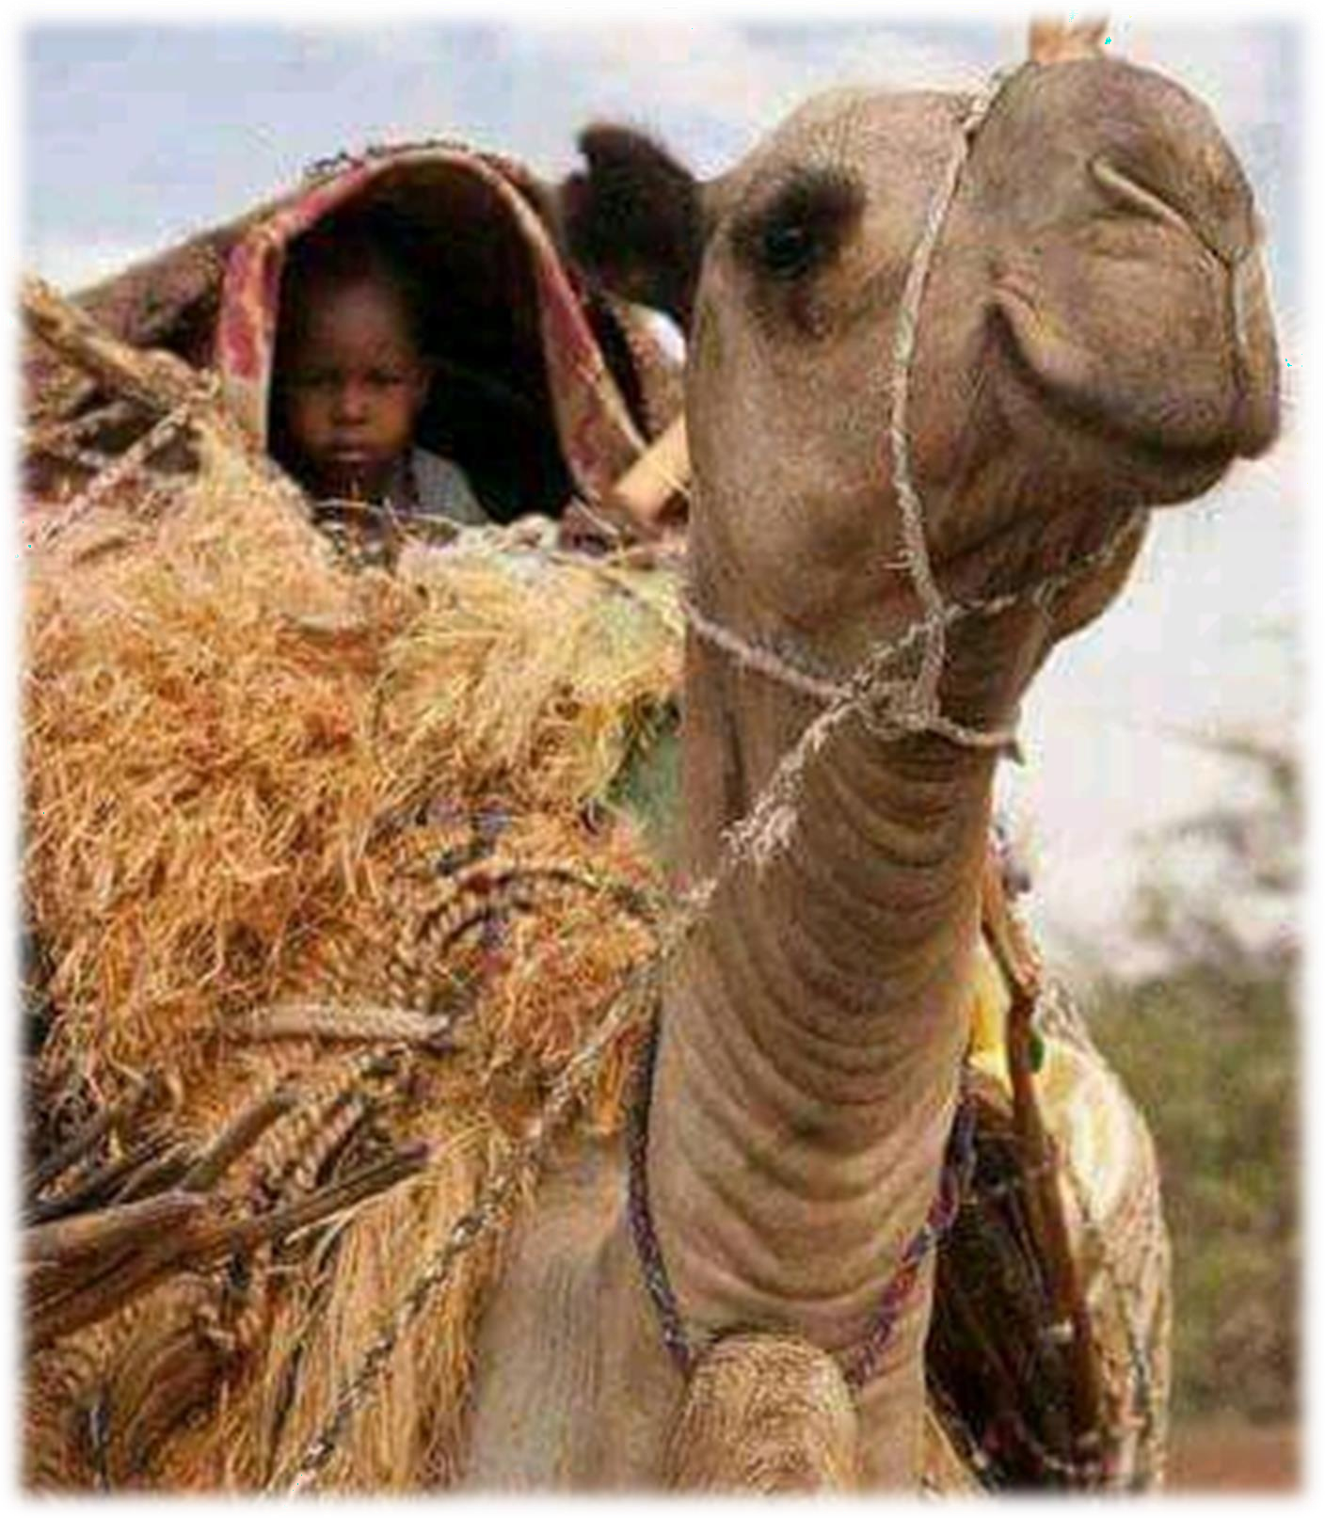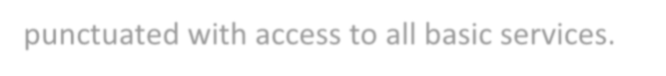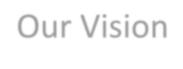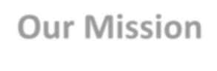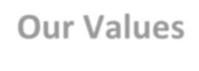

Our Vision



A fair and just society, with responsible and dynamic people working to transform communities for a better world.

## Our Mission

To reflect the best of humanity through positive interventions that seek to improve the quality of life for the under privileged in society

## Our Values

Pooling resources together in an atmosphere of trust, respect and commitment

FOAD believes in the human dignity of the poor, vulnerable and marginalized communities and strives to uphold this dignity.

FOAD believes that every human being has a right to decent living conditions punctuated with access to all basic services.

# Our Strategic priorities

Page 3



**FOAD Board of Directors**

**Country Director**

**Programs Director**

**Programs Manager**

**Programs Manager**

**Solutions**

**Finance Manager**

**Development**

**Program Officers**

**Accountant**

•

•

•

**Program Officers**

* Project planning
* Technician
* Community development
* Tracing & Humanitarian responses officer

•

Data manager

analysist Supply Chain Third Party Monitoring

M&E officer

**Administrator**

# Project Implementation

Page 4











# Solutions Services

Page 5











Page 6

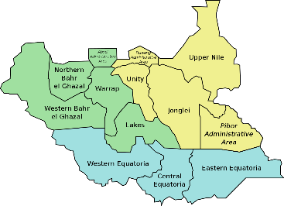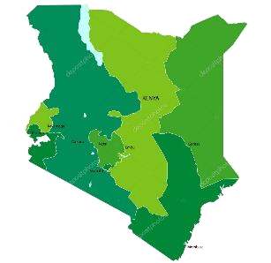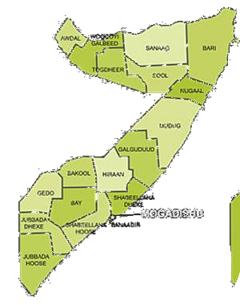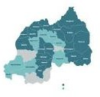

# Footprint



 

























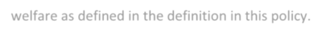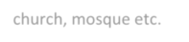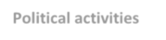

FOAD will not in any way support, activities that are political or Religious in their approach or focus on welfare as defined in the definition in this policy.

**Religious activities**

Evangelical activities are designed to convert people from one religious faith or denomination to another or from one political persuasion to another. Evangelical activities also encompass building church, mosque etc.

**Political activities**

Activities that could be construed as being political are those that involve “party” politics or

partisanship. or political structures including training and organizational activities.

General support for political participation does not fall within this definition of “political”, examples

of such general support could include civic awareness campaigns or activities that

promote the participation of women as political candidates (without promoting specific parties).

Page 7

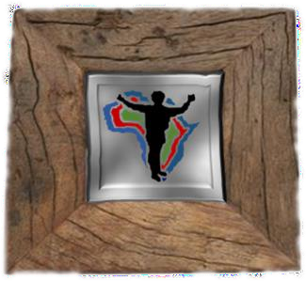

## Our Policies

#### Child Protection Policy











**Religious, Political & Welfare activities policy**

# Gender Policy

Page 8

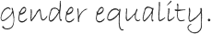

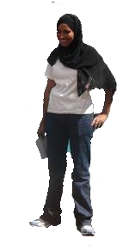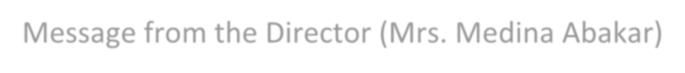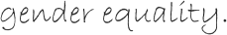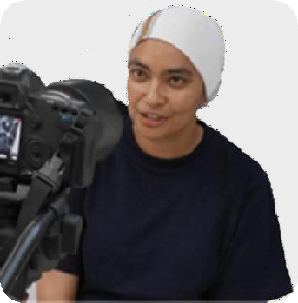

Message from the Director (Mrs. Medina Abakar)







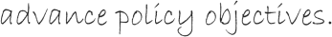





Page 9



“Strengthening compliance in places where access is limited”

























Planning: Expectations, Standards and Due Diligence:













Collaborative Approaches:







Page 10











 



 









### Water Sanitation and Hygiene

Page 11

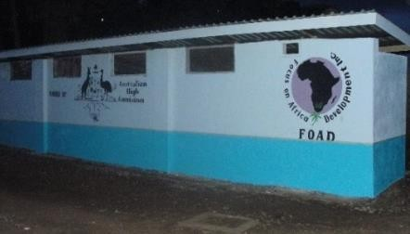









#### School health program.



















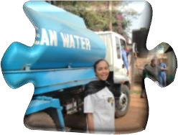**Improving Availability and Access to Portable water by house-holds**

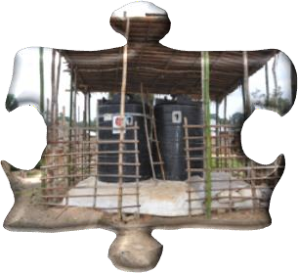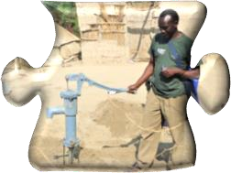

















Page 12

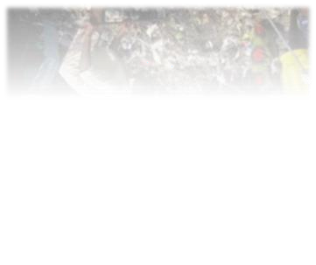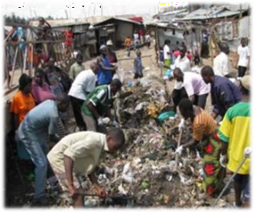

**Environment**

#### Sustainable Cities Program





















 



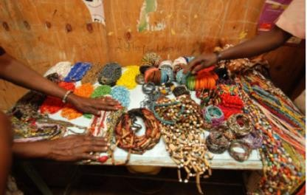• 

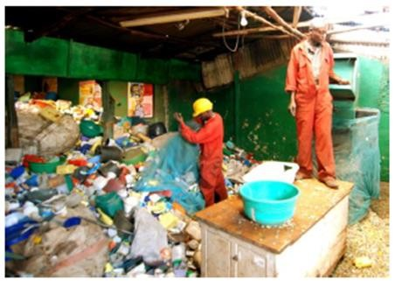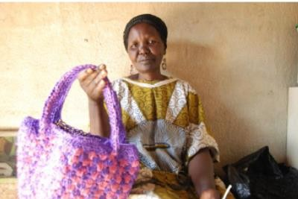

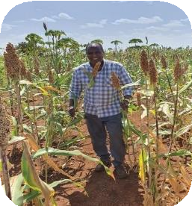

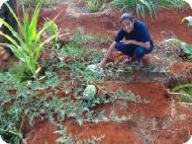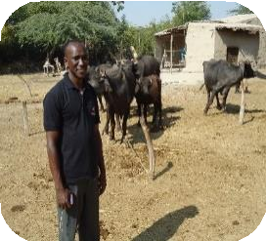

Supporting Livelihoods Page 13

#### Livelihood Development





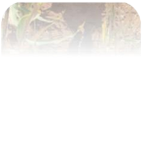







**Agroecological Project**















 



 





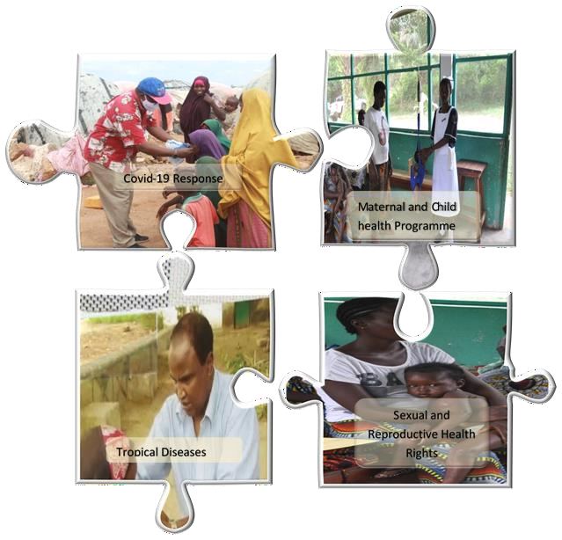

Page 14



#### Health care program

















 







Page 15



#### Covid-19 response and prevention



















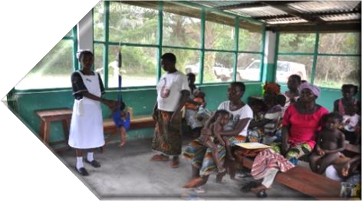**Maternal and child health program**



 



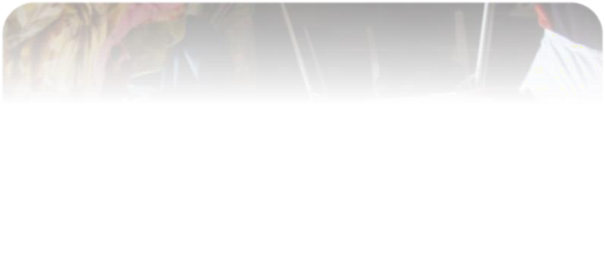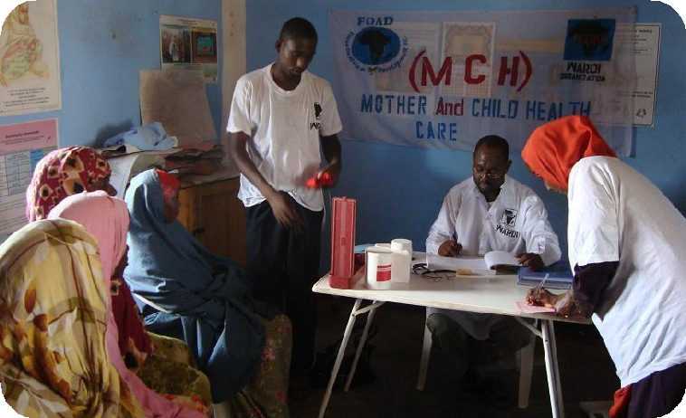

Page 16



**Tropical diseases response program**



















 

 



 

 

 



Page 17



#### Sexual and Reproductive Health Rights





















 



 







#### Humanitarian Response

Page 18

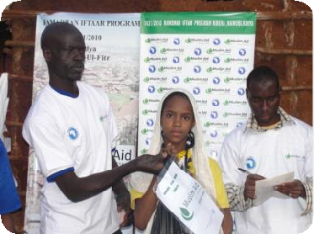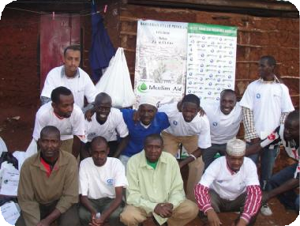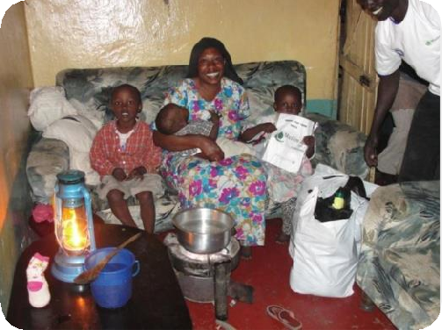



















 









 



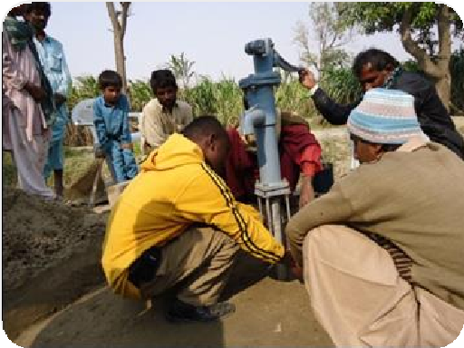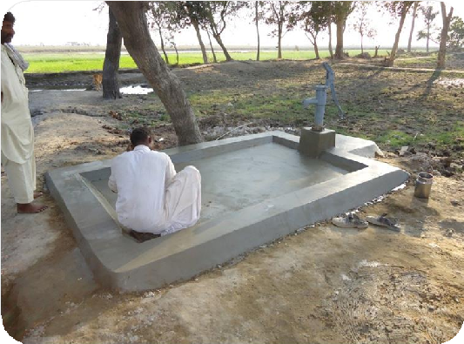

Page 19

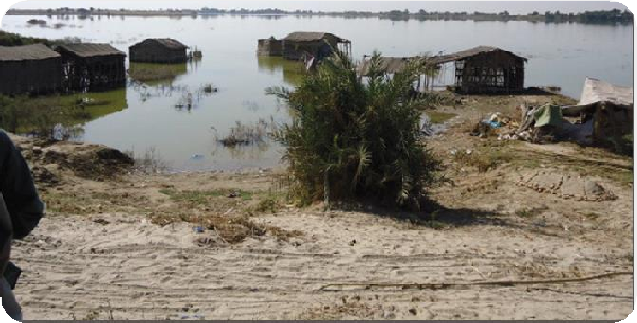

**Pakistan Flood relief**







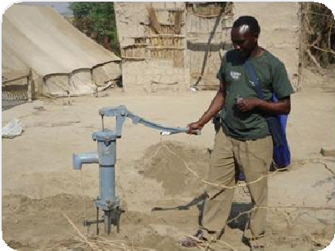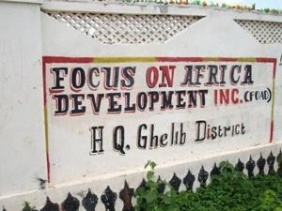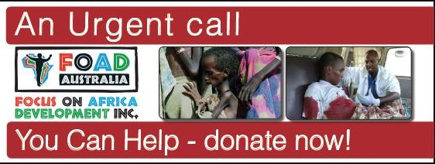

**A snap Shot of our history**

Page 20

